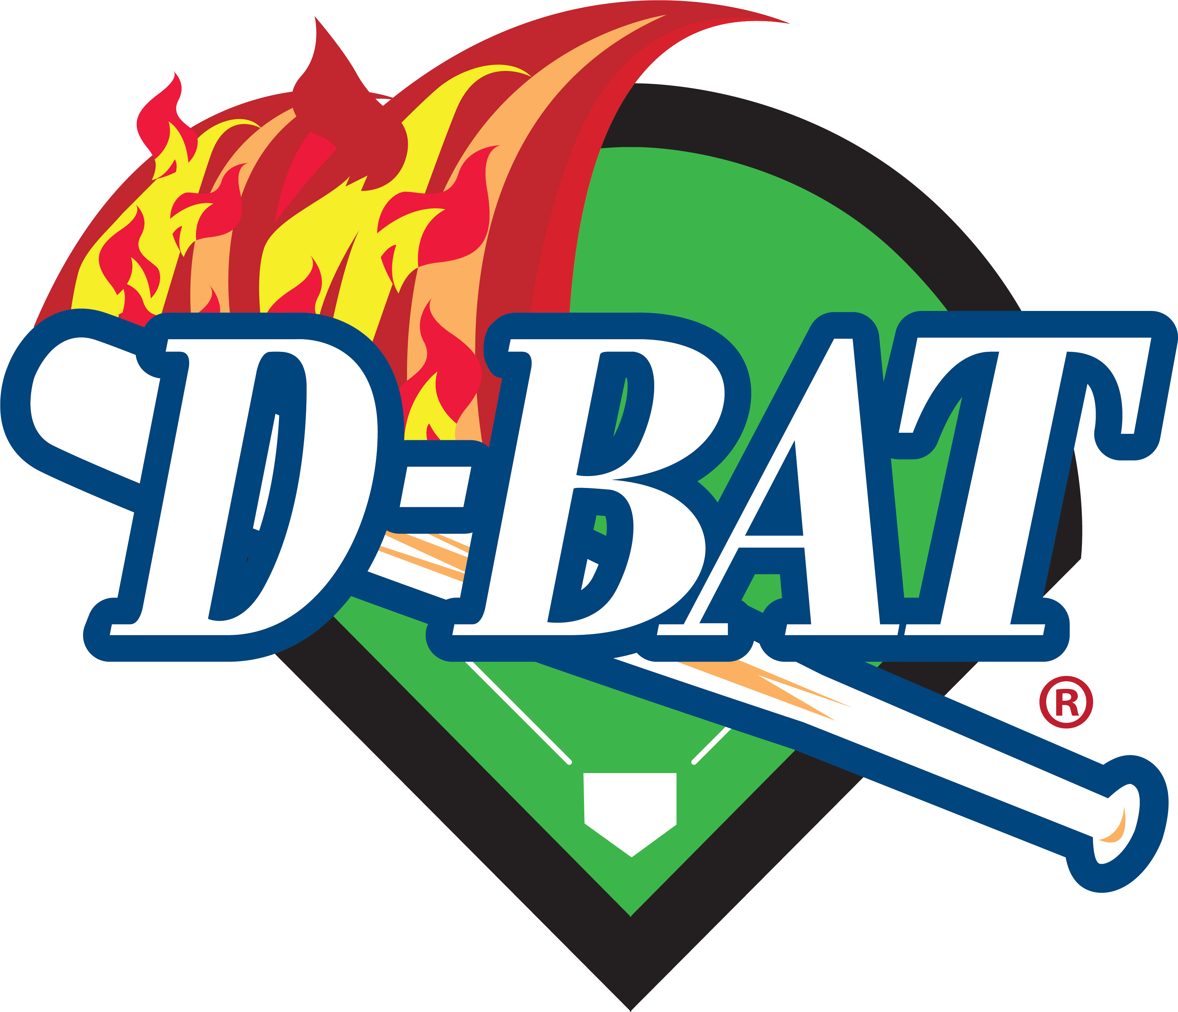
WAIVER AND RELEASE OF LIABILITY
NOTE: THIS FORM MUST BE READ AND SIGNED BEFORE THE PARTICIPANT IS PERMITTED TO TAKE PART IN ANY USAGE OF THE FACILITIES OR EQUIPMENT AT D-BAT HUNTERSVILLE. BY SIGNING THIS AGREEMENT, THE PARTICIPANT AFFIRMS HAVING READ IT.
IN CONSIDERATION of being allowed to participate in any way in the facilities, equipment, lessons, and/or rental, Swing It Boys 29, LLC d/b/a (“D-BAT Huntersville”), I, the undersigned, acknowledge, understand, and agree that:
1. I RISK BODILY INJURY, INCLUDING PARALYSIS, DISMEMBERMENT, DISABILITY AND DEATH, AND while particular rules of the sport, skills, equipment, and personal discipline may reduce this risk, THIS RISK OF SERIOUS INJURY DOES EXIST, AS WELL AS THE RISK OF DAMAGE TO OR LOSS OF PROPERTY; and,
2. I KNOWINGLY AND FREELY ASSUME ANY AND ALL SUCH RISKS, both known and unknown, EVEN IF ARISING FROM THE NEGLIGENCE OF THE RELEASEES OR OTHERS, and assume full responsibility for my participation; and,
3. I willingly agree to comply with the stated and customary terms and conditions for participation. If, however, I observe any unusual significant hazard during my presence or participation, or if I observe any concern in my readiness for participation, I will immediately bring such to the attention of the nearest D-BAT Huntersville employee and remove myself from participation; and,
4. I, FOR MYSELF, and on behalf of my heirs, assigns, personal representatives, and next of kin, HEREBY RELEASE, INDEMNIFY, HOLD HARMLESS and PROMISE NOT TO SUE D-BAT Huntersville, their officers, officials, volunteers, employees, agents, and/or other participants, sponsors, advertisers, and, if applicable, the owners and lessors of premises used for the activity (“RELEASEES”), WITH RESPECT TO ANY AND ALL INJURY, DISABILITY, DEATH, and/or LOSS OR DAMAGE TO PERSON OR PROPERTY, WHETHER CAUSED BY THE NEGLIGENCE OF THE RELEASEES OR OTHERWISE, to the fullest extent permitted by law.
I have read this Release of Liability and Waiver Agreement, fully understand its terms, understand that I have given up substantial rights by signing it, and sign it freely and voluntarily without any inducement.

Participant’s Signature ____________________________________________
Age:_________________
Participant’s Name (Printed)______________________________________
Date Signed:_____________

FOR PARENT/GUARDIAN IF PARTICIPANT IS A MINOR UNDER AGE 18)
(IF PARTICIPANT IS UNDER AGE 18 AT TIME OF REGISTRATION) This is to certify that I, as parent/guardian with legal responsibility for this Participant, do consent and agree not only to the release above regarding this Participant’s participation at D-BAT Huntersville, but also for myself, and my heirs, assigns and next of kin, to release and indemnify the Releasees from any and all Liability incident to my minor child’s involvement as stated above, EVEN IF ARISING FROM THE NEGLIGENCE OF THE RELEASEES, to the fullest extent permitted by law.
Parent/Legal Guardian Signature__________________________________
Date Signed: ____________
Parent/Legal Guardian’s Name (Printed)_______________________
Emergency Phone:_____________
Participant’s
Name(Printed):__________________________________________Age:___________

ADDITIONAL HELMET WAIVER
I understand that for my safety D-BAT requires me to wear a helmet when using the facilities, training services and equipment. In consideration of D-BAT waiving the requirement to wear a helmet when I use the slow pitch softball batting or pitching cages (whether being pitched by machine or person) I agree to the following.
I represent that I am an adult over the age of 18 and am of sound mind and body and capable of making this waiver, indemnity and release.
In consideration of being permitted to use today, and on all future dates, the facilities, training services, and equipment provided by D-BAT, I, for myself, my heirs, personal representatives or assigns, ASSUME THE RISK OF NOT WEARING A HELMET, AND DO HEREBY RELEASE, WAIVE, DISCHARGE, AND COVENANT NOT TO SUE D-BAT, from liability FROM ANY AND ALL CLAIMS, INCLUDING CLAIMS RELATED TO ALLEGED NEGLIGENCE OR BREACHES OF CONTRACT OR WARRANTIES BY D-BAT, resulting in personal injury, accidents, illnesses (including death), or property damage or monetary loss, arising from my not using a helmet in my participation in the use of the facilities, training services or equipment provided by D-BAT.
I agree to INDEMNIFY AND HOLD D-BAT HARMLESS from any and all claims, actions, suits, procedures, costs, expenses, damages and liabilities, including attorney’s fees, brought as a result of my use of D-BAT provided facilities, training services or equipment without a helmet.
Name ______________________________________________________
Address ____________________________________________________
Signature ___________________________________________________
Date ______________________________________________________

